**(2) Refugee Issues + 1st General Elections**

(Not for prelims this is important for mains.)

Refugee crisis:

3:35 time

08:27

11:57

Refugee crisis:

Immediate issue:

1. The people of Bengal and Panjab faced great uncertainty since the boundary commission had not finalized its awards even by the day of partitions. It was finally announced 17 august 1947.
2. Fether feeling of communal hatred by Jinna direct action program had complicated the situation.
3. There was an added sense of anxiety, going to lack of political awareness regarding details of partitions.
4. Chaos erupted area such as Lahore which Hindu s had expected will remain part of India was given to Pakistan. While both India and Pakistan assured their Minorites of protection neither could avoid large scale communal genocide.
5. Pakistan was never really serious for protecting the minority. The law-and-order machinery was not equipped to handle such a crisis, rape murder and looting were routing 1 crore people force to flee their home towards uncertain future.
6. With more than 10 lack mercilessly slaughter. Women and elder were the worst affected. Life, property and dignity were under constant threat.
7. Those who survive suffered immense sense of loss and emotional trauma migrant from the west Pakistan creamed into northern and western India over the several months.
8. With little preparation for this influx of migrants they are forced to live under the open sky. Roadside railway line or makeshift camp.
9. Refugee camps were set up at Amritsar, Jalandhar, Ambala, Faridabad, Delhi to provide shelter, food, water security medicine and clothing for the refugees. However, western and eastern India did not witness comparable relief effort for the million of refugee from the Sindh and east Bengal.

Rehabilitation effort:

1. Following the provision of immediate relief, the next task before the authorities was to rehabilitate the refugee and prepare them to rebuild their life.
2. In this scenario, we must consider the regionals response of western, northern, eastern separately.

Northern India.

1. The bulk of refugees in these regions came from the western Punjab.
2. A rehabilitation commission was established at Jalandhar in order to resettle them, give them new means of living hood, provide them housing, organized the borough to reunite missing persons with their relatives.
3. The unique aspect of migration of this belt was two sided.
4. Thus, it was relatively easier to resettle the incoming refugees.
5. One of important task before the rehabilitation commission was to carry out the land distribution program, in First stage the small parcel of land is allocated to every family. On the basis of claimed loss feather redistribution was carried out.
   1. Initially a small parcel of land was given to each refugee family. Feather redistribution claimed loss and graded cut.
   2. Refugees who did not come from farming background were allotted plots of land to build the home. Feather they are given the soft loan and financial assistance to build the small business.
   3. Despite this effort the general complaint was that the rehabilitation efforts were insufficient to restore the pre-independence living standard.

40:48 time

40:55

Western regions:

(Ahmedabad, Surat, Bombay regions)

1. The bulk of migrants in this region were from Sindh. Compare to the situation of north India who shared the culture of new homeland, situation in western India Is completely different.
2. Sindhi migrants felt like outsiders in their homes.
3. The Gujrat Maharashtra belt experience the serge of linguistic showiness following independence,
4. The Sindhi migrant faced the discrimination at the all the stages. And the administration remains apathetic towards their plight.
5. Sindhis were forced to acclimatize culturally shedding their distinct their linguistic and cultural identity.
6. This represented an irredeemable loss cultural heritage. That is not possible to recover from while the Sindhi community has been able to rebuild its economic and social status. The loss of their identity remains the bitter tragedy.

01:00:40

Eastern India:

1. In this sector the migration of refugees was one-sided. That is from the east Pakistan towards India therefore they’re virtually now land or property to redistribute.
2. Fether the bulk of incoming immigrants either the marginal present or unskilled labor, thus there were no practical job opportunities for them.
3. As such for year they continued to be suffered in the extreme poverty. Where the government is not in the position to give them relief.
4. Further many refugees fled toward the north-east of India state Manipur and Tripura. Causing the sudden demographic transition resulting in emergence of permanent political tensions.

01:09:42

01:10:48

Impact of refugee crisis:

1. Refugee crisis left a bitter test on the national tongue it was the product of communal hatred which creates the feather communal tensions. The painful memory of communal holocaust continuous to fuel this hatred even today.
2. Demographic transition: migration of refugees also resulted in the major demographic transition on the basis of culture, language and ethnicity. For Pakistan it represented almost complete loss of its religious diversity. However, in India it resulted in the culture transformation. Ex Delhi lost its pre independence Indo-Islamic with heavy influx refugees from the Panjab
3. Feather in some sectors the ethnic composition was transformed in the major way. The ex tribal dominated area of Manipur and Tripura were flooded by the sudden influx of Bangla people.
4. Political trends shifted sharply as a result of refugees crisis. Marginal political parties and cultural groups found the ready recruit among the incoming stream of aggrieved refugees.
5. In the Delhi Panjab belt the RSS gain good will among refugees by providing them with good relief and rehabilitation. Thus it was able to ideologically recruit the younger ones similarly in west Bengal found the ready subscribers from the poor streams of migrants and gain popularity.
6. Partition and the refugee crisis also emerge as important theme of artistic expression. Several dramas, novels, short story, and film, poem, song covered the life struggle hopes fairs tragedy and achievement of refugees.
7. It emerge as most prominent theme of Urdu, Hindi, Panjabi, literature, during the 1950 and 50. Ex
   1. Tobatak Singh (Urdu novel) written by Sadat Hasan Manto.
   2. Train to Pakistan: (English novel) by Khushwant Singh
   3. Pinger (Panjabi drama): Amrita Pritam.
   4. Tamas (Hindi novel) by the Bhishma sahani
8. Partitions and refugee crisis also cast long shadow in the India foreign relation they permanently embittered the relation between India and Pakistan. Feather the humanitarian tragedy associated by the partition was exploited by the major power broker during the cold war.
9. The large-scale influx of refugees. Gave major economic set back to the Indian economy. It derailed the process of economic rebuilding as valuable fund has to diverted from development to the relief

Q. discuss the problem faced by the refugees coming to India following partition how were these overcome?200 w 15 marks

Ans:

Q. The refugee crisis following the partition of India represent the largest force migration in the human history. In this context discuss the significance of this in Indian and world history.

Refugee crisis (1070-71) BLW (Bangladesh liberation war)

Redefining the pol. Map of sub- continent

Destabilize the global feather.

Block politics:

Establish the pattern and precedence in the world politics

Dilution of the commitment of prevalent / diffuse conflicts.

Migrant asylums.

Iraq and Syria.

Cuba + DR+ Haiti.

01:45:55

Demographic and cultural Transformation:

Influx of large number of Asian and African -Europe.

Latina Americans

This has resulted in the anti – immigration sentiment:

Strengthening of Right wing pollical / Trends

This may result in the De-globalization.

01:51:53

Democracy and first General Election (1951-52)

1. Evolution of democracy during the National movement.
2. Challenges.
3. Special feature of the election and its process.
4. significance

01:57:29

Evolution of democracy during the National movement:

1. ever seen the establishment of congress it had been advocating or popular responsive government.
2. It stood for the introduction of collective responsibility, popular sovereignty, limited government, self-determination and universal franchise.
3. With time the national movement evolve from the urban phenomena into true all India mass movement. With participation from every region and section of pollution.
4. The choice before the constitution maker was clear. Any things different from true representation democracy would be betrayal of values of national movement as well as willful undermining the India’s rich diversity.
5. However, different conditionals differ with respect to approach. For example, American type democracy or British type democracy.

Challenges:

Challenges in conducting the general election

1. India inherited the series of problem that threatens its very survival including refugee crisis food crisis, war with Pakistan, religious and ideological extremism, in this scenario organizing the general election may have been dangerous.
2. Impact within Nehru’s cabinet there is no unanimity, some wanted to delay the election while others suggested the limited franchise.
3. Nehru emerges as statement deciding to conduct election as soon as possible to restore the public fate. He feels that the masses would not be able to experience real freedom till they exercise the right to vote.
4. Roughly 80-85% of masses were illiterate and yet to be registered. There was risk of dis-enfranchisements, voter fraud, low voter turnout, and vote bank politics.
5. Feather ensuring neutrality the election was another major challenge. Free and fair elections were vulnerable to law-and-order problems in many states, money and muscle power, social structure based on caste, religion and gender and petty corruption.
6. Legitimizing the election in the eyes of the international community is another challenge. Many schoolers and foreign leader doubted the India’s ability to even survive and let alone undertake free and fair election at such a large scale. Therefore, success was crucial not only to ensure integrity of democratic institution to legitimizes the India as whole.

(3) 1st General Election + Tribal Integration

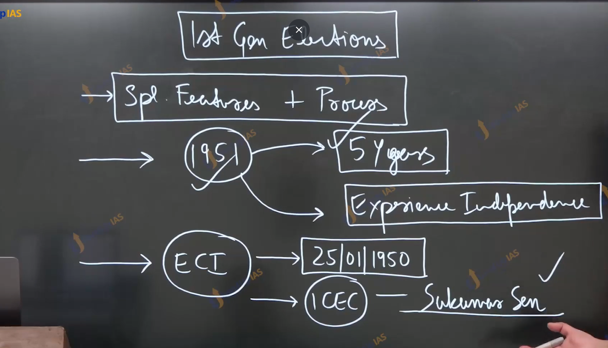

Special features and process:

1. Pandit Nehru facing steep opposition to conduct elections at the earliest. He reasoned that people of India would taste the real fruit of independence only when they are elected their own government.
2. Further this would also align with constitutional deadline of 5 year. The election commission of India was established 25th jan 1950. With one chief election commission Sukumar Sen ICS officer with math background
3. Further representation of people acts 1951 provided for election houses of parliament and state legislature. The election commission used Government school teachers to register voters and prepare electoral roles. Once complete this process had to repeated due to present of over 35 lack suspicious names.
4. Simultaneously the election commissions training officials, setting up polling center and boots and organizing the transportation and security.
5. Party symbols are prepared to help the voter by overcoming the high level of illiteracy.
6. Since with was not feasible to conduct the election in the one sweep it was decided to conduct them over the several phases over the 4 months. (Oct 1951 to Feb 1952)
7. Campaigning was done through print media. Pamphlets and posters were widely circulated as parties organized public meetings and rallies. Leaders went from door to door to meet voters and ask for the vote. However, all India radio was prohibited the from broadcasting from any electoral material.
8. Returning officers were appointed in every constituency to ensure the fairness of elections by enforcing the modal code of conduct.
9. On the day of elections, the atmosphere resembles the festivals voter turnout is healthy and 58%. The highest being Kottayam (Kerala) (84%) , and lowest been Shahidul (18%) in MP.
10. Different political parties had campaigned around the different agendas
    1. The congress promised good governance, poverty removal and minority protection.
    2. The communist campaign on the piler of workers and peasants’ rights including the land reforms and workers participation in the management. They blamed the congress for protecting the middle-class interest.
    3. The Hindu Mahasabha campaign on the promoting the Hindu culture. They criticized the congress for appeasing the minorities.
    4. Doctor Ambedkar campaign for the Dalit rights and criticized the congress for ignoring them.
    5. Pro Hindi group promised to make Hindi the national language.
    6. The DMK campaign on the platform on Tamil pride. And promised to prevent Hindi to becoming the national languages.
    7. The congress won the majority of seats in the parliament and state legislator. There were some upsets such as dr. Ambedkar and Morarji deshi how are unable to get elected. However most prominent leader won their constituencies win with large majority.

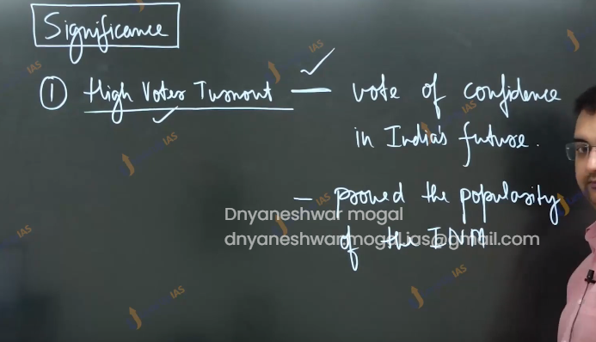

Significance:

1. The high voter turnout: indicated the hopeful mode of masses towards India’s future they felt they contributed to it by constructive by participating in elections.
2. Further it silences the Indian nationalism and Indian national movement how had been arguing that Indian nationalism merely elite concept imposed upon the masses. The high voter turnout assisted the polarity to the ground level.
3. 1st time that all Indian could participate directly in the political life in the nation. One person one vote. For 1st time universal adult Frenchie was enforced this was revolutionary developments
   1. This was the 1st occasion when the ordinary masses got the opportunities to participate the in the political life of nation.
   2. Political equality in the form of one person one vote became the basis for greater degree of socio-economic equality in country that remained the deeply divided on the based caste religion and gender line.
4. The election also shattered the myth that India’s illiterate masses was unfit for popular democracy they overcame sectarian thinking and vote bank polities and back the congress progressive and secular agenda.
5. The success of election dispels the doubts and silenced the critics of Indian democracy. India was successful in the overcoming serious challenges including economic burden, social divide, security concern and threat of foreign interference.
6. The first general election also legitimizes the constitution. Not only did the voters uphold the constitution electoral process but simultaneously also retrospectively gave popular support to constitution assembly members who were elected to parliaments.
7. The composition of Lok Sabha reflected the diversity of nation having the representation from all the regions and backgrounds and classes. In other words, the first general election transforms the parliament into microcosm of nations.
8. The success of elections also international acclaim for India special among the specially decolonizes country who looks towards India as role model.

Q. Discuss the special features of the 1st general election of India. In this context, analyses the significance. 200 words.

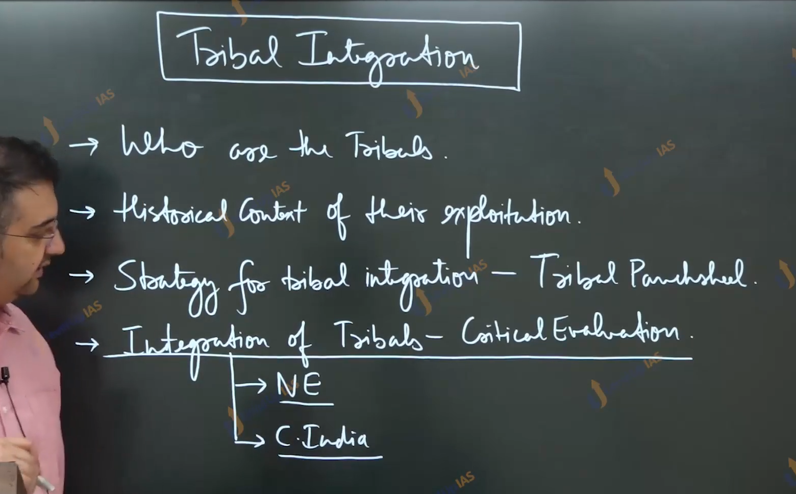

Tribal integration:

Who are the tribals:

1. Trible are a group of people living in relative isolation in the forest and hilly regions with distinct identity and culture. Presently tribal constitute the roughly 8% of India’s population with north-east India and Central India being two major concentrations.

Historical context of their exploitation:

1. Histrorically, their contact with mainstream society was rather limited.
2. During the phase of British capitalist expansion as the out sider began entering the tribal habitat in search various economical resources like agriculture land, timber, markets, revenue and religious convert.
   1. This included farmer, zamindars, money landers, contractors, traders, professionals like doctors, teachers and lawyers, and Cristian missionaries.
   2. Apart from a few, all these groups brutally exploited the tribals. Their freedom, identity and culture were under constant threat.
   3. Therefore, the conflict between the tribals and outsiders was a natural phenomenon. As result, British rule witness the series of tribal uprising.
3. Ultimately the British took certain major to provide the relief the tribals such as creation of separate tribal divisions with their own administrative machinery. And the appointment of officials with special power to provide for tribal well fair. However, due to lack of sincerity, had little impact beyond the introducing the culture of neglect.
4. National movement had also largely failed to draw the participation of tribal. This was due to
   1. Lower literacy, relative isolation and thus lower penetration of nationalist sentiments.
   2. Suspension of all outsiders
   3. Lack of sufficient initiative by the nationalistic leadership to engage the tribals.

Strategy for tribal integrations:

1. Following independence, different Scholler express the different opinions regarding the strategy for the tribal integrations.
2. Two major situations occurred
   1. To integrate the tribal to mainstream society.
   2. To keep them completely isolated.
3. While the former strategy had been implemented in the north America. The later attempted Australia. However, neither yield satisfactory returns.
4. In this scenario, pandit Nehru searching for different approaches when the British anthropologist Verrier Elwin suggested the strategy for tribal integration on their own terms.
5. On the basis of this strategy, Nehru postulated the Tribal Panch-Sheel.
   1. Development with their own genius.
   2. Land protected.
   3. Language is much protected and promoted.
   4. Local administration.
   5. Minimal Administration.

Integration of Tribals: Critical evaluations.

North-East India

1. After independence Northeast India was re-organized into grater assam regions. Assam (reorganization act 1951) and Northeast Frontier agency. (NEFA)
2. NEFA was given the status of union territory 1971 and full statehood in 1986 in the form of Arunachal Pradesh. The principle of tribal panchsheels were implemented with the sincerity in this region resulting in the smother process of integration.
3. In the peripheral area of greater assam tribal hill council were established however, the principal of Panch Sheel were not sincerely implemented.
4. The policy of Assamisation was perused in the heavy interferences in tribal administration and imposition of Assamese language.
5. Ultimately grand tribal allies emerge against this policy and movement become the violent.
6. 1959 a Garo, Khasi and Gayantias. Were given greater autonomy and all powers except for HIGH COURT, Governor, Public Service commission, Legislative assembly.
7. In 1969, Meghalaya was made sub-state Thruough the assam sub-state act 1969.
8. Through the northeast territorial reorganization act 1971 Meghalaya, Manipur, Tripura. Were given full statehood.
9. In 1955 the Naga led by Pzphizo declared independence resulting the lengthy period of insurgency. Finny the moderate group Led by the Dr. ImcongLiba Ao had persuaded them to drop the demands for spiritism. In 1962 state of Nagaland created by the removing the area of naga hills and Tuensang from assam.
10. Here thought separatist movement emerge under the Lal denga finally the accord was sign between the Missos and government of India 1996 and it was given full statehood.

Central India:

1. In the central India, tribal are spread across wild belt covering the Chhattisgarh, Jharkhand, orisha and Telangana and Andhra Pradesh along with parts of Maharashtra and Madhya Pradesh. Unlike northeast India tribal in the minority with extremely socio-economic conditions levels.
2. The major issues they faced include.
   1. Backwardness.
   2. Under-representation.
   3. Economic exploitation of their natural resources and
   4. Displacement land acquisitions
3. As a result, there is widespread protest and clashes before as well as after independence. Ultimately resulted in the emergence of a powerful tribal movement known as Jharkhand Movement.
   1. The Earliest tribal leader was Jay pal Singh who founded the Jharkhand party in the 1950 and demanded and creation of a separated state for tribals.
4. The States re-organization commission rejected the demand for the creation of Jharkhand. With this demand for Jharkhand become the louder. In the 1970s the radical movement muti movement emerge under the leadership of Shibu Soren Guruji they enter with the alliance MCC (Marxist -Communist-center) and began the violent movement.
5. Ultimately, they entered an agreement with the government to give up the violence and enter democratic politics.
6. They secured the several seats in the tribal dominated area. But remained little importance in national politics.
7. During the co-olation area the JMM gained prominence by bailing out the PV Narasimha Rao. Ultimately the state of Jharkhand was created along with state of Chhattisgarh Through the Bihar re-organization act and the MP re-organization respectively.

Constitutional provisions and protection.

1. The constitution of India had put in the place several protections for the tribals including
   1. schedule 5 and schedule 6.
   2. Create tribal advisory council.
   3. ST commission to look after the tribals welfare and overseen the implantation of varies policy and schemes benefiting the tribals.
   4. Reservation in the
      1. Lok Sabha (7.5%)
      2. State legislative (proportion to their population.)
      3. Employment and Pub. Education.
   5. Special power to governor to some state with tribal population.
   6. The welfare scheme forcing upon the promotion of education, skill development, poverty removal, sanitation, access, and preservation of tribal knowledge and tribal languages.
   7. While these have resulted in disable changes such as better health in diseases, better literacy, better sex ratio and greater political empowerment, feather efforts needed since tribals continued to remains among the most vulnerable section among the Indian population.

Q. Discuss the problems faced by the India’s tribals at the time of Independence. How were their problems overcoming and with what degree of success.

Ans :